**Fourth Increment**

**CS5590BD**

**Group 12**

**GLTRON**

**Project Goal and Objectives:**

Gaming is an interesting domain and always growing. Interactive gaming is slowly gaining popularity with touch screen, mouse, keyboard, keypad, joystick, etc all becoming obsolete. There is a growing demand for close to reality gaming. Gaming input ranges from plain hand gestures, sensor gloves, sensor cords, and so on. We use Texas Instruments sensor tag (TI Sensor Tag) in our game to pass the input signals.

GLTron is an enthusiastic game which is about tactical racing. It is a six player game out of which 5 players are operated by the computer. A player has to ride his bike. The trail leaves a colored marking (wall). So, a player has to control his bike and keep it from running into others’ walls or obstacles. One must also not hit a wall created by oneself. The color of the wall made by each player is different. We can maneuver the bike using sensor tag. We can also view the statistics of the game played. When you click the ‘Show Stats’ button, you get a pie chart of all the movements of the sensor tag.

**Game by Motion/ Activity Report:**

**Devices/ Sensors:**

We use the Texas Instruments Sensor Tag (TI Sensor Tag) and HTC One Android mobile phone

**Motion Models:**

There are basically 4 gestures in our game. They are:

Left 🡪 Left turn

Right 🡪 Right turn

Up 🡪 Pause

Down 🡪 Exit

We already have sequence files of the trained data. The new gesture data is collected using the sensor tag and then a sequence file is generated for this data. Now, this sequence file will be compared with the trained sequence files and the appropriate gesture is detected.

**Game Logic:**

We have basically 4 things to look at when we implement this game. They are shown below:

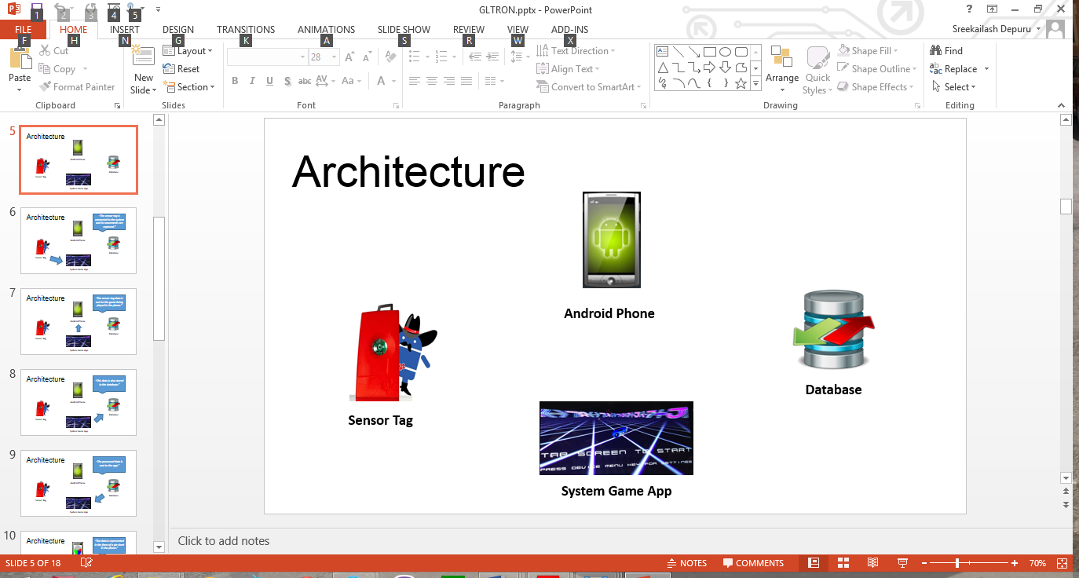

We can explain the working of the project by means of the following figures:

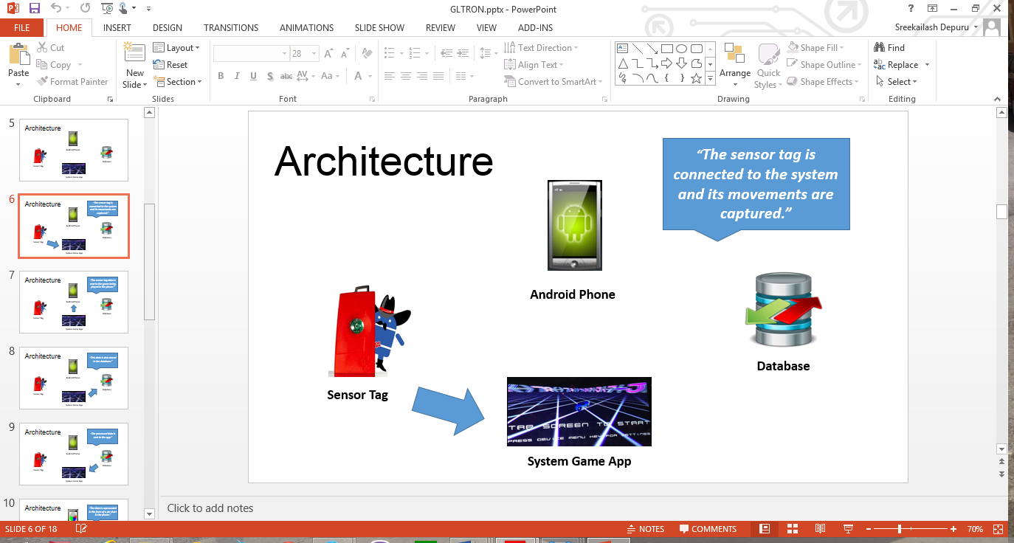

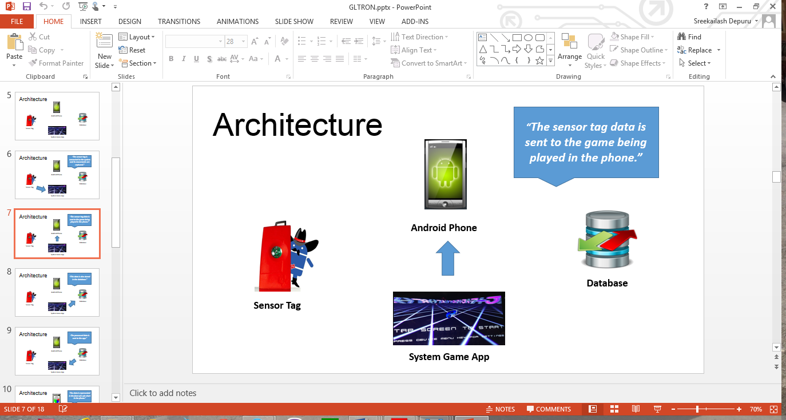

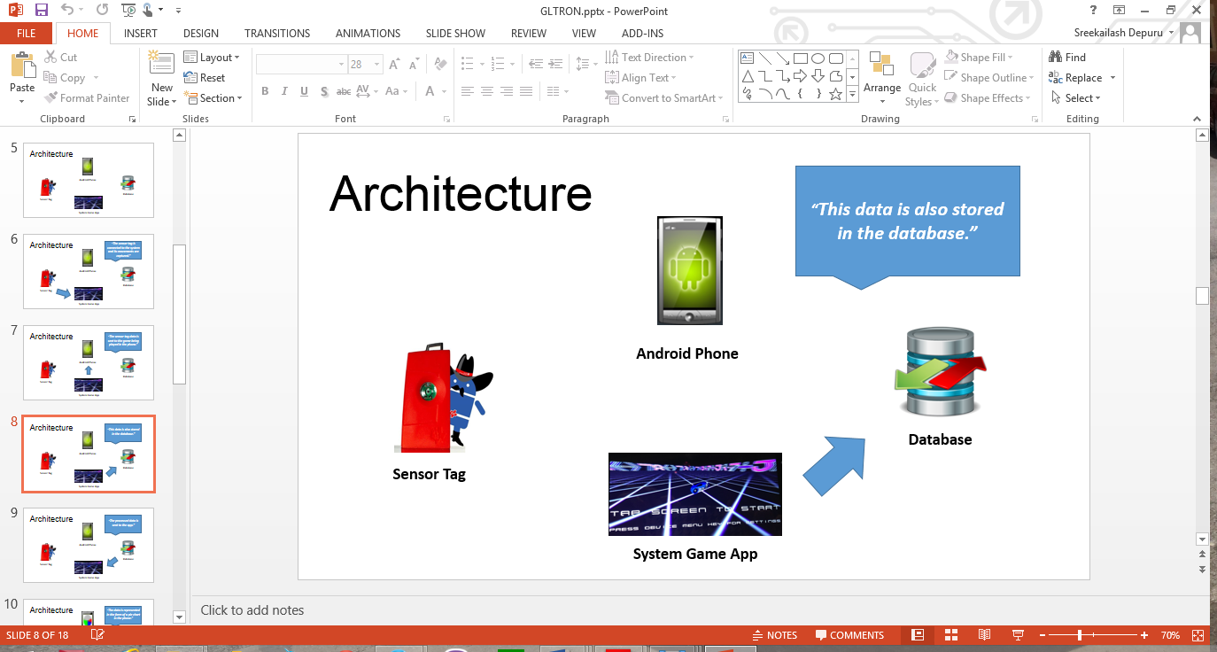

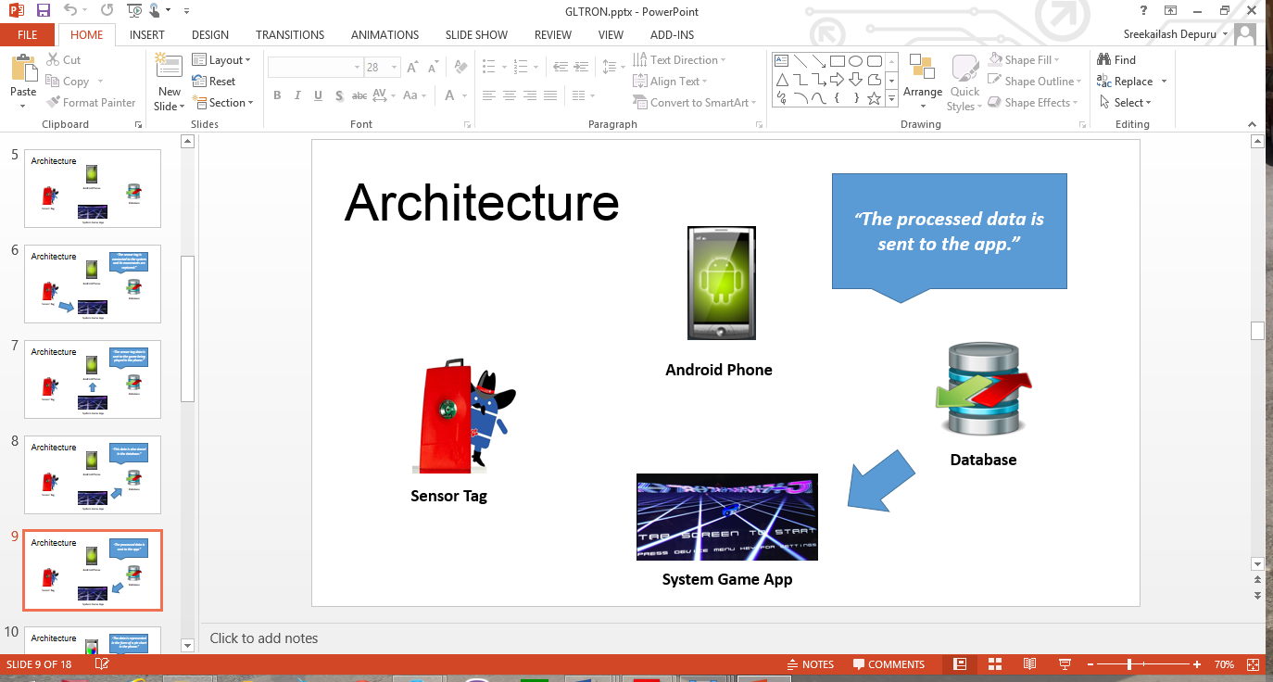

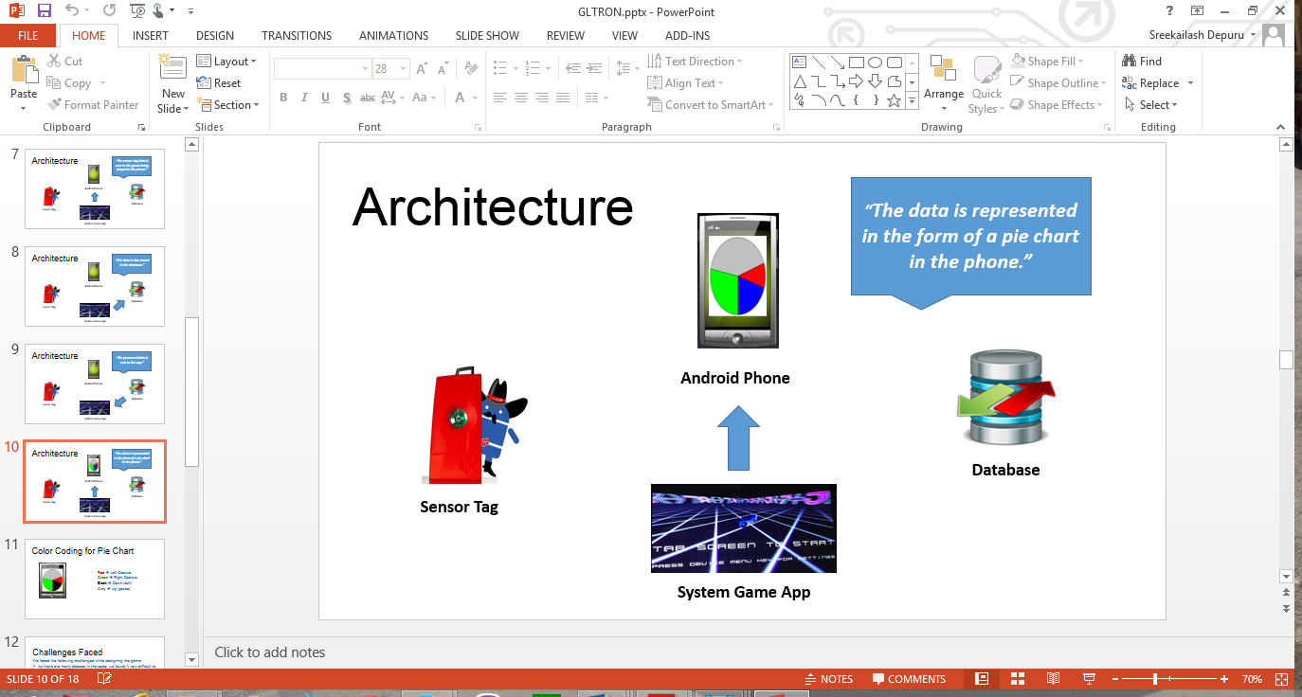

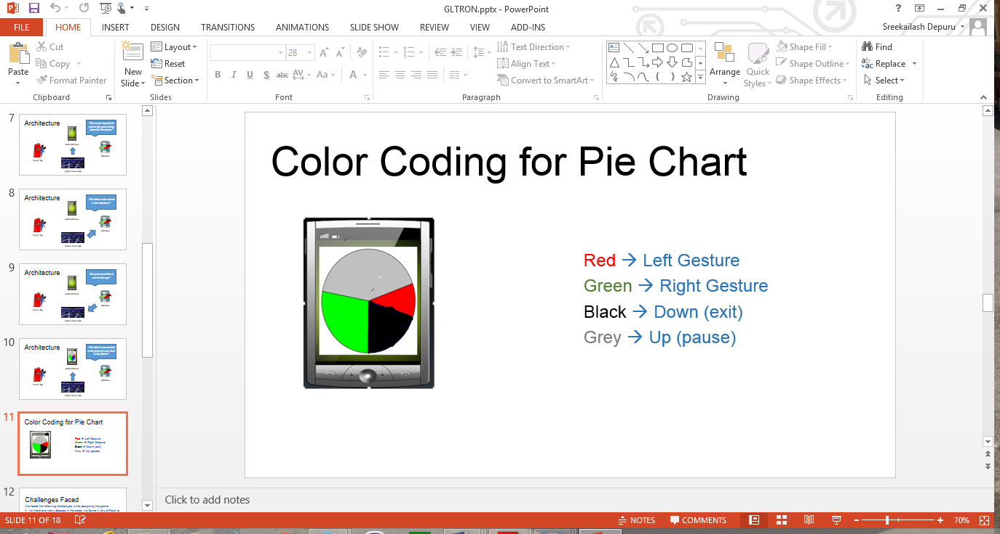

**System Features and Android App GUI:**

The system requires the TI Sensor tag with the highest Bluetooth version compatibility. The android device used must also be of the highest version possible to see better results.

The picture below shows the Home Screen of the game. This screen allows user to either to start the game or view the statistics of all the games played.

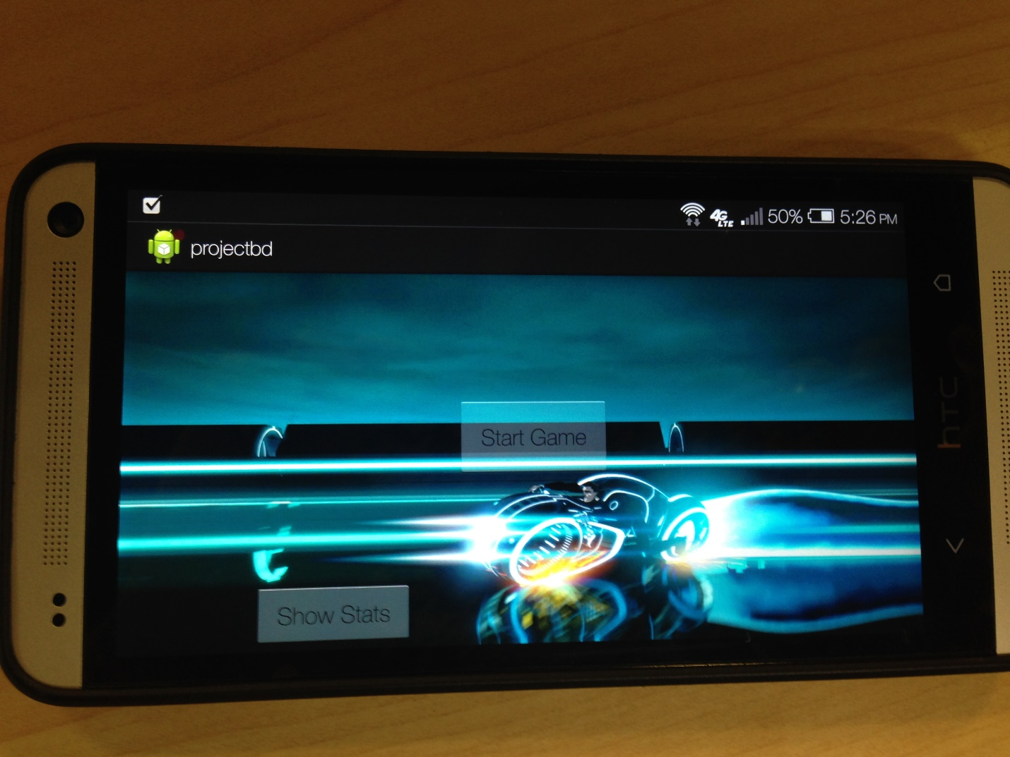

The following screen shows what happens after selecting Start Game option:

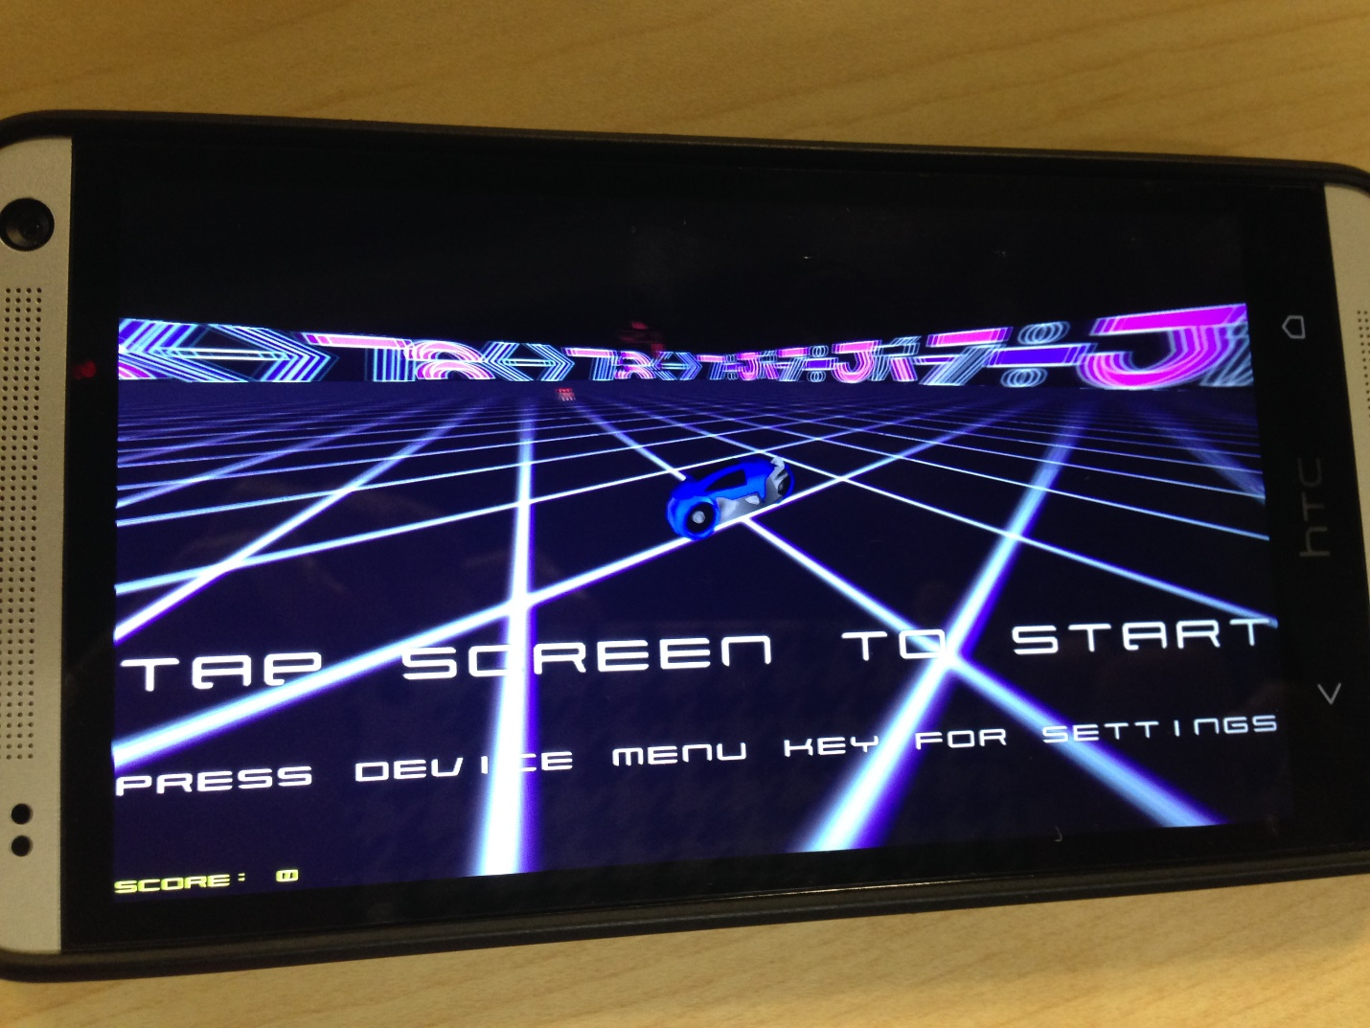

**Evaluation: Motion/Activity Recognition**

**Number of Users:**

There is only one user in the game. This is a 6 player game in which one player is the mobile app user and the other 5 are operated by the computer.

**Types of Motion/Activities:**

We can maneuver the bike using sensor tag. The various movements of the sensor tag are as follows:

Left 🡪 Left turn

Right 🡪 Right turn

Up 🡪 Pause

Down 🡪 Exit

**Size of Data, Number of Gestures:**

We use 4 distinct gestures and the size of data for each trained gesture is found to be around 20-25 KB. But each training file has a huge number of values which are found be good enough for detecting the activities.

**Data Preparation and Accuracy:**

The data has been collected using the sensor tag. We use this data for machine learning to generate the sequence files after capturing each gesture.

We had a problem with the accuracy initially with the value being 60%. But, we reduced the speed of the bike in the game which brought a significant rise in accuracy by 30% making it 90%.

|  |  |  |  |
| --- | --- | --- | --- |
|  | Precision | Recall | F-Measure |
| Left | 0.667 | 0.75 | 0.706 |
| Right | 0.71 | 0.625 | 0.664 |
| Up | 1 | 0.625 | 0.77 |
| Down | 0.8 | 1 | 0.889 |

**Limitations:**

We faced the following challenges while designing the game:

* As there are many classes in the code, we found it very difficult to back track turnleft() function. It is very difficult to sift through so many classes in the code.
* The speed of the bike is very high in the game. There is a lag in the capturing of sensor information while playing the game. So, we reduced the speed of the bike so that the sensor data is captured accurately.

**Future Work:**

There can be a few additions to this game like

* Multiplayer gaming facility wherein multiple players can play at once using their mobile phones.
* There can be a provision of some additional powers and points to keep the players motivated.
* There can be a jump feature to make the game more competitive.
* We can also make the game online on facebook so that people can invite their friends to participate in the game.
* We can have different arenas to play in.

**Project Video:**

**Related Work:**

There are a few more versions of GLTron developed by android game developers like Loki and others. They are all inspired by the movie Tron which led to the development of this game.

**Bibliography:**

<http://www.gltron.org/>

<http://www.gltron.org/download.php>

<https://play.google.com/store/apps/details?id=com.glTron&hl=en>

<http://en.wikipedia.org/wiki/GLtron>